

A Case Study of Environmental Monitoring

Barry Williams
barryw@databaseanswers.org
www.databaseanswers.org

1. Summary of BMEWS
Database Answers Ltd publishes a Road Map for Enterprise Data Management.
This Case Study describes how the Road Map was used to design and build an Environmental Monitoring System called BMEWS in London, England.
BMEWS stands for the ‘Business Monitoring and Early Warning System’.
The principle was to use Traffic Light displays to apply ‘Management by Exception’ to highlight problems requiring attention.
Key Performance Indicators,(‘KPIs’) were defined as the percentage of Red, Amber and Green within specific Areas, called Wards.
These KPIs were then compared against Threshold values and the appropriate colour of Red, Amber or Green was chosen to display the result for each Ward.
These Observations were then transmitted to a remote Database where they were consolidated to produce totals of Red, Amber and Green for specific smaller areas within the overall area being monitored.
BMEWS used State-of-the-Art technology:-
  - Smartphones were used to enter basic Observations Streets, including Photos.
  - Internet technology was used to transmit Observations to a remote Database
  - SQL was used to calculate KPIs
  - A Traffic Light display was used to show the results to senior management
  - Reports were delivered over the Internet.

2. Data in BMEWS
This diagram shows that Observations are entered using Smartphones.
They are then transmitted to a remote Database using an Internet protocol.
Finally, Key Performance Indicators are calculated and displayed to senior management.
Key Performance Indicators (‘KPIs’)

DATA MART
Data Layer of Totals

Data Layer of Basic Monitoring Observations

3. As seen by Senior Management
The mission statement was to “To maintain a Clean and Green Environment”.
Typical Key Performance Indicators include percentage of Green for specific areas within the overall environment.
Green would be all areas are rated more than 90% on the ‘Clean and Green Meter’.
Amber would be between 50% and 90% and Red below 50%.
Of course, these values could be changed very easily by senior management.
The Director was able to see at a glance Red areas and call the responsible managers to discuss the problem with them.
This often led to a visit by the Cleaning team to rectify the problems.
Smartphone were then used to transmit the ‘Rectification’ to the remote Database and the Director was able to see the impact in a real-time mode.
This led to a greatly increased level of performance.
Using the BMEWS System, the manager with operational responsibility for the Cleaning Team was able to follow the activities of his team in real-time and make sure that they were following his instructions.
This is the view that all levels of management could see :-
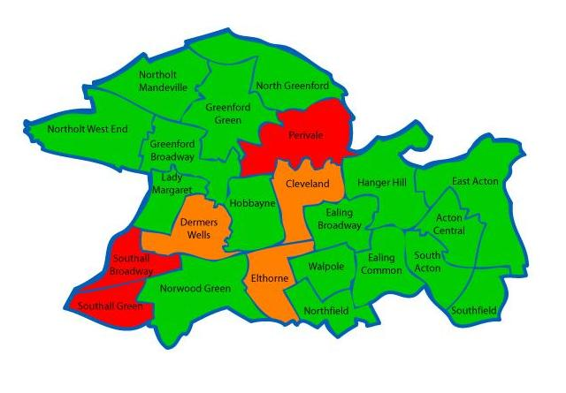

4. As seen by the Data Architect
The BMEWS Architecture was composed of three Layers :-
- The Top Layer provided Performance Reports
- The Middle Layer is the Data Services Layer
- The Lowest Layer is the Data Sources

Web Services are used to implement data movements between these three Layers.
- The Top Layer included :-
  - Traffic Light displays
  - Reports
  - Enquiries
  - Feedback
- The Data Services Layer included :-
  - Web Services for Data Integration and Consolidation
- Data Sources included :-
  - Inspections from the Monitoring Team using Smartphones
  - Rectifications from the third-party Environmental Clean-up Contractor
  - Monthly Schedules input from Spreadsheets

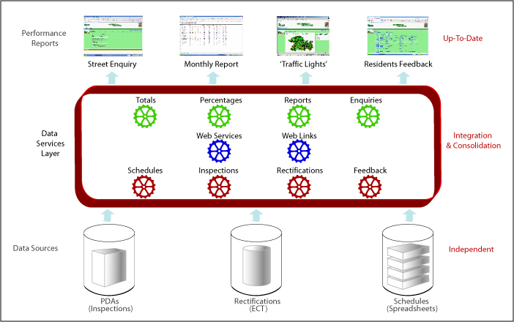

5. A Vision of the Future
This diagram shows the future of ‘Ubiquitous Data’
Data will be available at ‘Any Time, Any Place and using Any Device’.
We can see the beginnings of this with Smartphones that can be populated from libraries of Applications (‘Apps’) covering a wide range of functions.
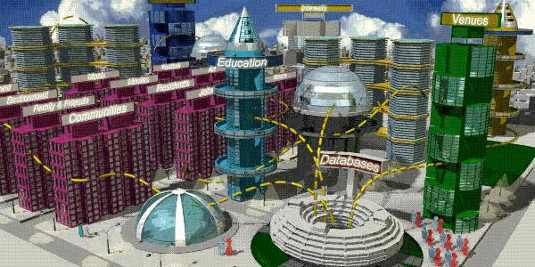

6. A Family Looks at the Future
This diagram shows the kind of information that a typical Family will need in the Future.
Current work is developing a Proof-of-Concept described on this page :-
- http://www.databaseanswers.org/Future_of_Databases/proof_of_concept.htm

