1 Introduction
2. Concepts
One-to-Many Relationships
Many-to-Many Relationships
Rabbit’s Ears
Inheritance
Reference Data
3 Data Warehouse
Design of an ERD
Design of a Data Warehouse
Reviewing the Design of a Data Warehouse
4. Applications
Customers and Demands
Units and Demands
Deliveries
Maintenance
Subject Areas

Barry Williams
Data Architect
Glue Ltd.

1 Introduction
The purpose of this document is to help in looking at a Data Model and understanding it.
It is based on the concept of Design Patterns which are general solutions to common problems which occur on a regular basis.

This document starts with some simple Concepts and then discusses common Applications that use these Concepts.

The document applies in two situations :-
i) Data Models created by Reverse Engineering existing Databases.
ii) Other Data Models.
This document will help in the Quality Assurance (‘QA’) of these Data Models, which might be
produced internally or externally, by Partners, for activities such as Data Migration.
.

i) For the first situation, it is not appropriate to try to do a Quality Assurance of the Model.
This is primarily because Databases in operational systems have usually gone through a series of changes and usually the impact on design has not been thought through and there has not been time to redesign the Database.
The objective is primarily to understand the Database.

The many-to-many Pattern will not occur because this cannot be implemented directly in a Relational Database. This applies also to Inheritance which can only be identified by implication.

It is often useful to create a general Business Data Model that renames Tables as appropriate to replace the physical Table names with corresponding Business Terms.

For complex Databases, it is usually valuable to create a Top-Level Data Model with lower-level Subject Area Models.

It is important to try to establish a Glossary of Terms, covering descriptions of the most important Tables and Attributes and Reference Data.
Another important activity is to establish the Business Rules that define the logic underlying any Database.

Some simple examples that can be used as Templates have been shown in this document.

ii) For the second situation, it is appropriate to do a Quality Assurance of the Model
This would include a number of tasks, such as :-
- looking for examples of the Design Patterns being used where appropriate.
- review of the Reference Data

2. Concepts
- One-to-Many Relationships
A Customer can place many Demands for Materiel.
This defines a One-to-Many Relationship.

A Data Modeller would say “For every Customer, there are many Demands”.
This is shown in a Data Model as follows :-

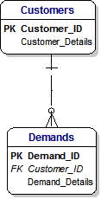

TERM | DEFINITION
Customer | Any Unit that can raise a Demand
Demand | A request for Assets to be supplied.  The format of a request can be an electronic message, a paper Form and so on.

Business Rules : A Customer can raise zero, one or many Demands.
: A Demand must be associated with a valid Customer.

- Many-to-Many Relationships
We can also say that a Demand can request many Products.
A Data Modeller would say “A Demand can request many Products, and each Product can be in many Demands”.
This defines a Many-to-Many Relationship and is shown in a Data Model as follows :-

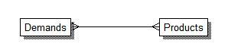

Many-to-Many Relationship cannot be implemented in Relational Databases.
Therefore we resolve this many-to-many into two one-to-many Relationships, which we show in a Data Model as follows :-

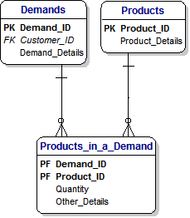

When we look closely at this Data Model, we can see that the Primary Key is composed of the Demand_ID and Product_ID fields.
This reflects the underlying logic, which states that every combination of Demand and Product is unique.
In the Database, this will define a new record.
When we see this situation in a Database, we can say that this reflects a many-to-many Relationship.
However, we can also show the same situation in a slightly different way, which reflects the standard design approach of using a surrogate key as the Primary Key and showing the Demand and Product IDs simply as Foreign Keys.

The benefit of this approach is that it avoids the occurrence of too many Primary Keys if more dependent Tables occur where they cascade downwards.
The benefit of the previous approach is that it avoids the possibility of ‘orphan’ records in the ‘Products in a Demand’ table.
In other words, invalid records that have invalid Demand ID and/or Product ID values.

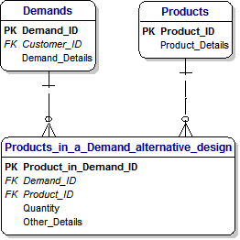

TERM | DEFINITION
Demand | A request for Assets to be supplied.  The format of a request can be an electronic message, a paper Form and so on.
Product | An Asset that can be supplied on request.  It can be something small, like a Washer, or something large, like an Aircraft engine.. The term Equipment is reserved for major items, such as an Tornado Aircraft.  The word Asset is used to refer to smaller items, such as Aircraft engines.  Products are also referred to as Materiel.

Business Rules : A Demand can refer to one or many Products.
: A Product can appear in zero, one or many Demands.
: In other words, there is a Many-to-Many Relationship between
Demands and Products.

- Rabbit’s Ears
We start with the definition of a Unit, which at its simplest, looks like this :-
In this case, we use a meaningless ID which is simply a unique number.

.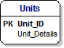

Then we think about the fact that every Unit is part of a larger organisation.
In other words, every Unit rreports to a higher level within the overall organisation.

Fortunately, we can show this in a very simple and economical fashion by creating a relationship that adds a parent ID to every Unit.
. This is accomplished by adding a relationship that joins the table to itself.

This is formally called a Reflexive relationship, and informally called ‘Rabbits Ear’s, and it looks like this :-

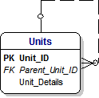

The Unit at the very top of organisation has no-one to report to, and a Unit at the lowest level does not have any other Unit reporting to it.

In other words, this relationship is Optional at the top and bottom levels.

We show this by the small letter ‘O’ at each end of the line which marks the relationship.
- Inheritance
Inheritance is a very simple and very powerful concept.
We can see examples of Inheritance in practice when we look around us every day.

For example, when we think about ‘Houses’, we implicitly include Bungalows and Ski Lodges, and maybe even Apartments, Beach Huts and House Boats.

In a similar way, when we discuss Aircraft we might be talking about Rotary Aircraft, Fixed Wing Aircraft and Unmanned Aicraft.

However, when we want to design or review a Data Model that includes Aircraft, then we need to analyse how different kinds of Aircraft are shown in the design of the Data Model.

We use the concept of ‘Inheritance’ to achieve this.
Inheritance is exactly what it sounds like.
It means that at a high level, we identify the general name of the ‘Thing of Interest’ and the characteristics that all of these Things share.
For example, an Aircraft will have a name for the type of Aircraft, such as Tornado and it will be of a certain type, such as Fixed Wing or Rotary.

At the lower level of Fixed-Wing Aircraft, an Aircraft will have a minimum length for the runway that the Aircraft needs in order to take off.

This situation is shown in the following diagram :-

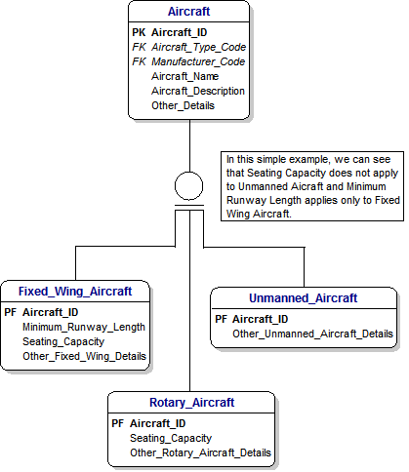

- Reference Data
Reference Data is very important.
Wherever possible, it should conform to appropriate external standards, particularly national or international standards.
For example, the International Standards Organization (‘ISO’) publishes standards for Country Code, Currency Codes, Languages Codes and so on.
For Materiel and Products, NATO has published the National Codification Bureau (NCB) code.
This is in use within the MOD and is administered from Kentigern House, Glasgow.

For Addresses, the UK Post Office Address File, ‘PAF’ File, is used to validate Addresses within the UK.
For Units, the overall structure is classified.
The Centre Top-Level Budget (‘TLB’), maintains SIMS which records the Unit Number, Name and Address for each Unit and is updated in response to updates from the TLB.

This diagram shows two basic examples of Reference data that might apply to our simple Aircraft Data Model.

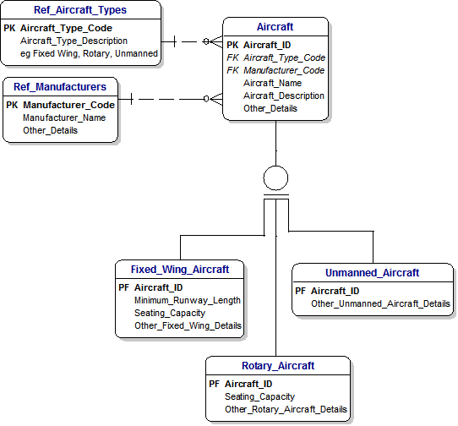

3 Data Warehouse
Design of an ERD
This Data Model is an Entity-Relationship-Diagram (‘ERD’) for Customers and Demands :-

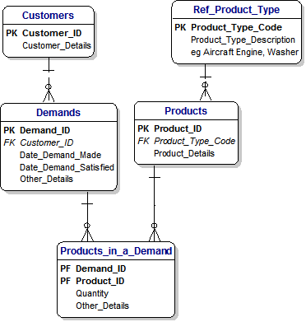

We could describe it in these terms :-
“Customers place Demands for Products of different Types.”

Design of a Data Warehouse
This Data Model shows the corresponding Data Warehouse for Customers and Demands :-
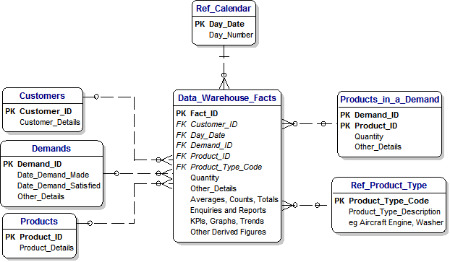

The design of this Data Warehouse simply puts all data into a ‘big basket’
Reviewing the Design of a Data Warehouse
The design of any Data Warehouse will conform to this patter with Dimensions and Facts.
Dimensions correspond to Primary Keys in all the associated Tables (ie the Entities in the ERD) and the Facts are the derived values that are available.

Therefore, reviewing the Design of a Data Warehouse involves looking for this Design Pattern.

With one exception, the Relationships are optional because the Enquiries need not involve any particular Dimension.
The one exception to this rule is that the Relationship to the Calendar is mandatory because an Enquiry will always include a Date.
Of course, an Enquiry might include all data since the first records, but the principle still applies.

The purpose of the Data Warehouse is to make it easy to retrieve data in any combination in order to answer questions like this :-
- Which Customers ordered the most Products ?
- Which were the most popular Products in the first week of April ?
- What was the average time it took to respond to demands for Aircraft Engines ?
- How many Demands did we receive in May ?

4. Applications
- Customers and Demands
The design of the ERD in the Chapter on Data Warehouses shows a typical Customers and Orders Data Model which represent a widespread kind of application.
- Units and Demands
Here is a slightly different Model showing Units instead of Customers and highlighting the power of Rabbits Ears.

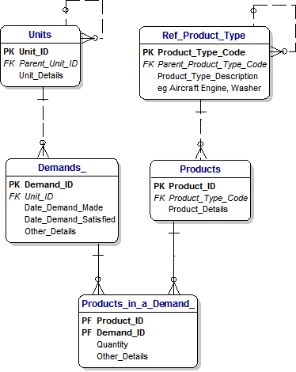

- Deliveries
A Simple Design Pattern
This Data Model is a simple Design Pattern that covers the activities of delivering items in a Demand to a designated address.
The process of reviewing a Data Model is to ask :-
“How do I describe the Business Rules behind this Model ?”

In this case, we could say :-
“A Customer can raise a Demand for Products to be delivered to a specified Address”.

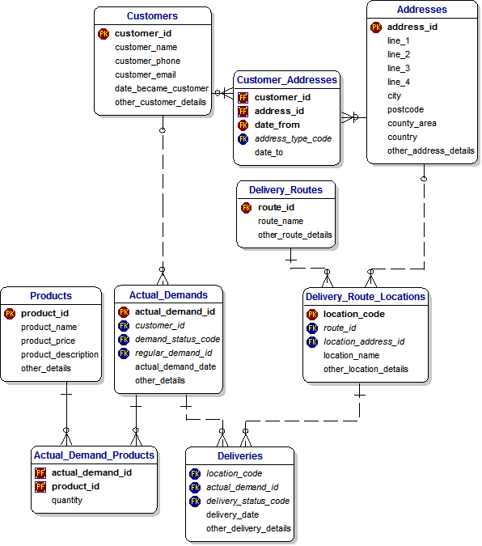

- A Complex Design Pattern
This shows a complex Pattern which adds Regular Demands.

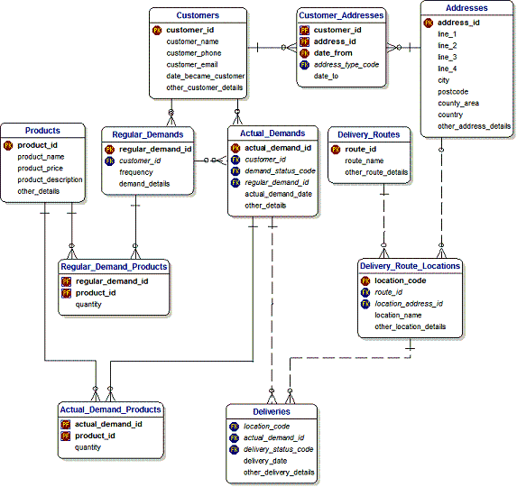

- Maintenance
The scope of this Data Modelis the Maintenance of Assets by Third-Party Companies.
The Business Rules state :-
* An Asset can have a Maintenance Contract.
* An Asset consists of Asset Parts
* Faults occur with these Parts from time to time.
* Third Party Companies employ Maintenance Engineers to maintain these Assets.
* Engineers pay Visits which are recorded in a Fault Log.
* They correct the Faults and this is recorded in the Fault Log.

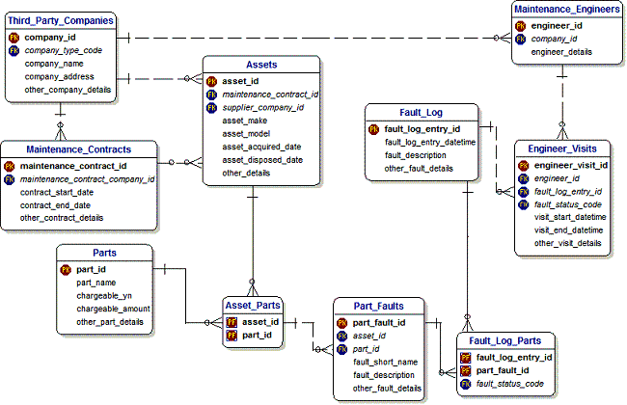

- Subject Areas
Complex Data Models which are common in large organisations can best be understood when they are broken down into a Top-Level Model and Lower-Level Subject Areas.
Typical Subject Area Models are Deliveries and Maintenance.

These are shown in earlier Sections of thsi document.

Top-Level Model
This is a top-level Model showing the Entities that are important at the top level.
It provides a suitable form of communication with a wide range of stakeholders.

A lower-level Model has been created for each specific Subject Area.

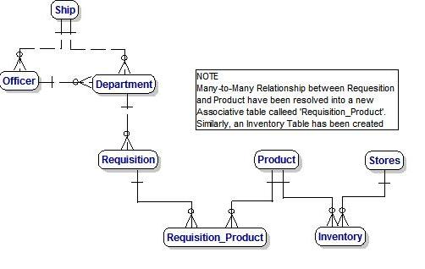

Barry Williams
Data Architect
Glue Ltd.

